**HTTPS for Consumer**

**If we want to consume third party service and if it is “https” then use this**

**Applicable for HTTP and SOAP nodes only**

**Step 1:First put https URL in chrome browser and download certificate**

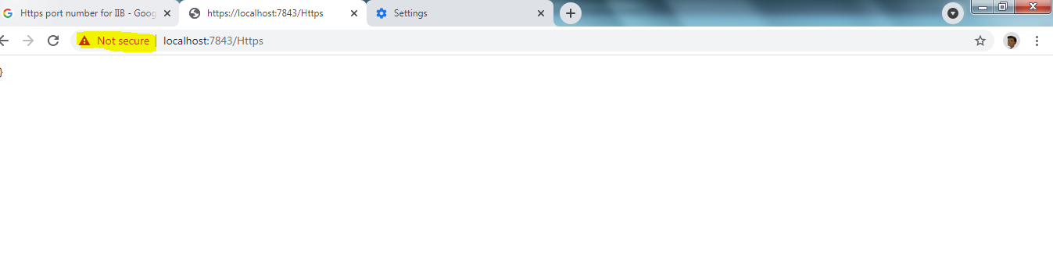

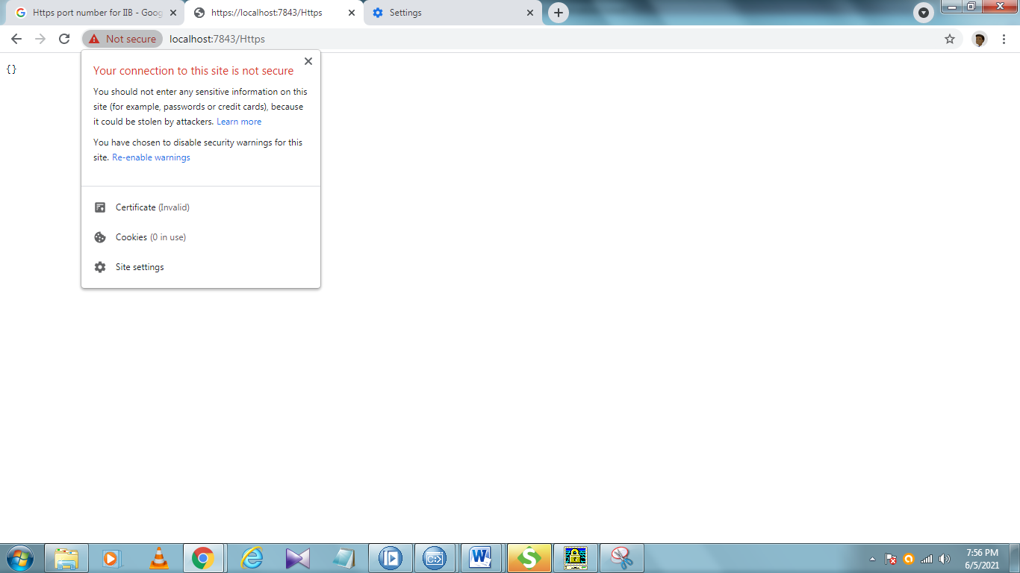

**Click on Certificate**

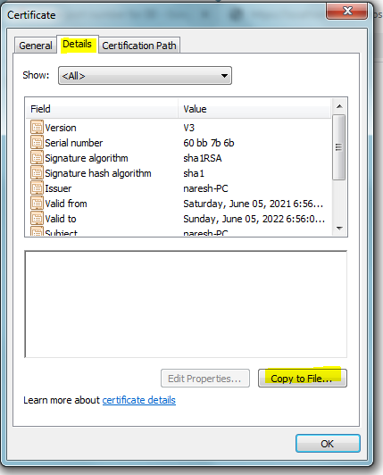

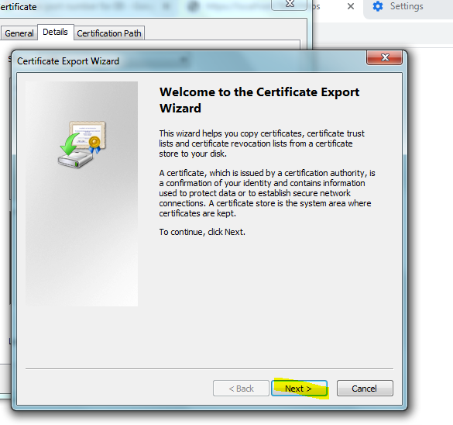

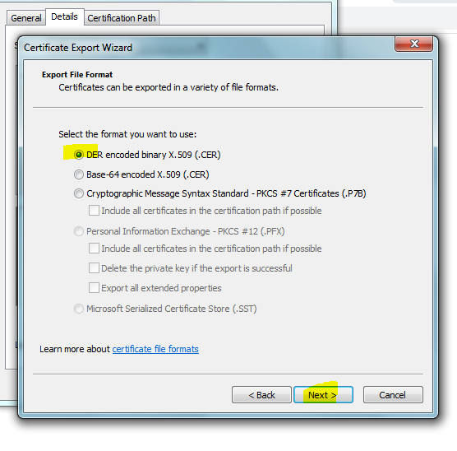 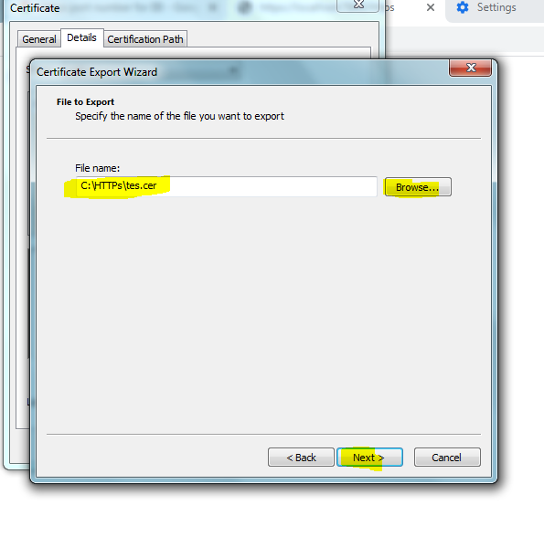

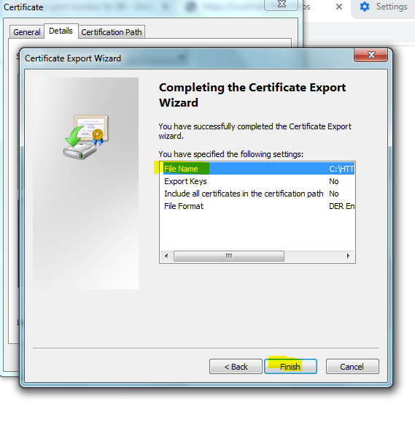

**Step 2 :Next create truststore**

Type **ikeyman** in console enter

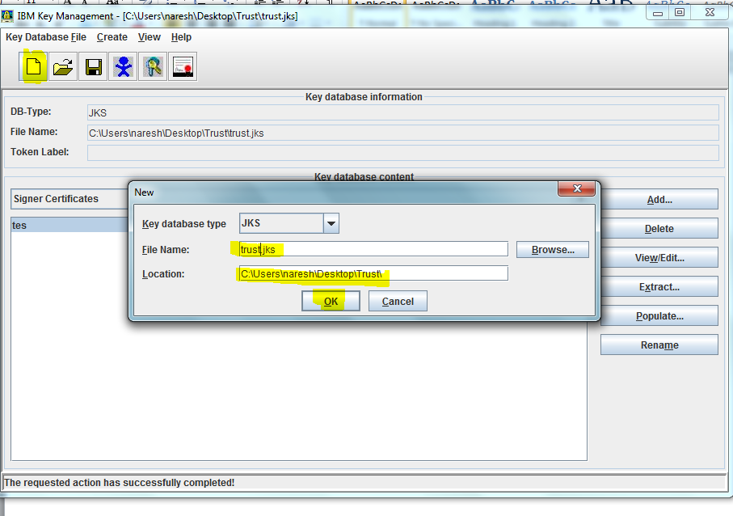

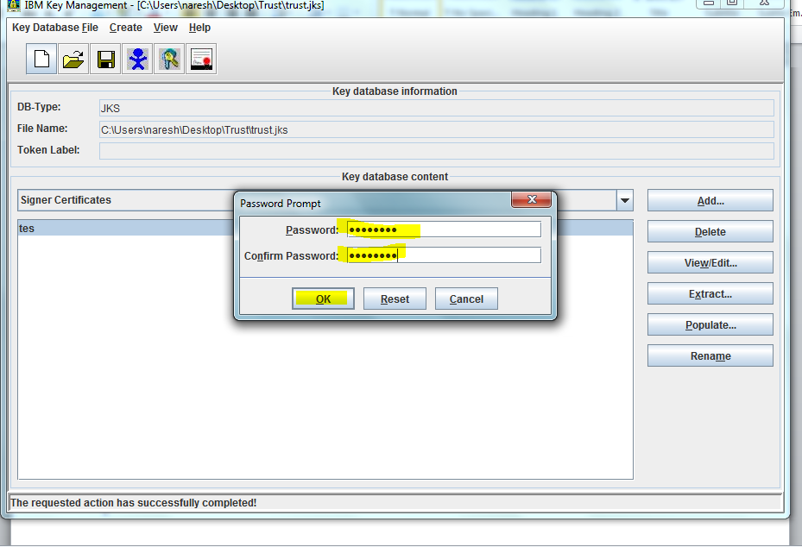

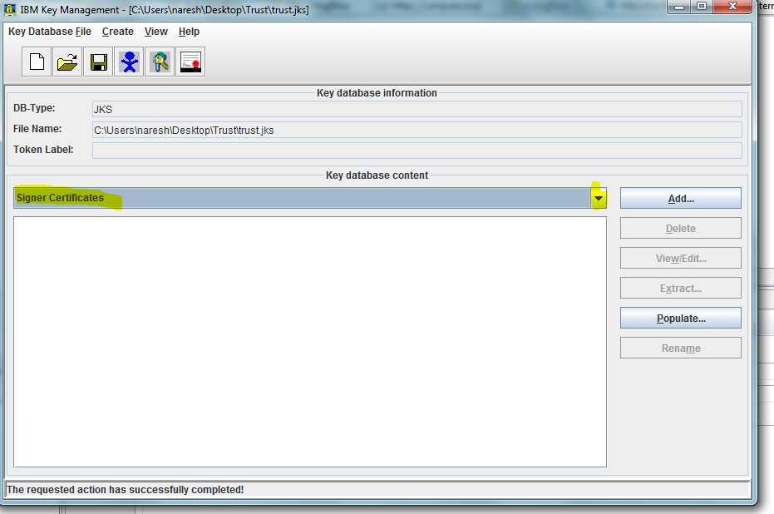

From dropdown choose signer certificate

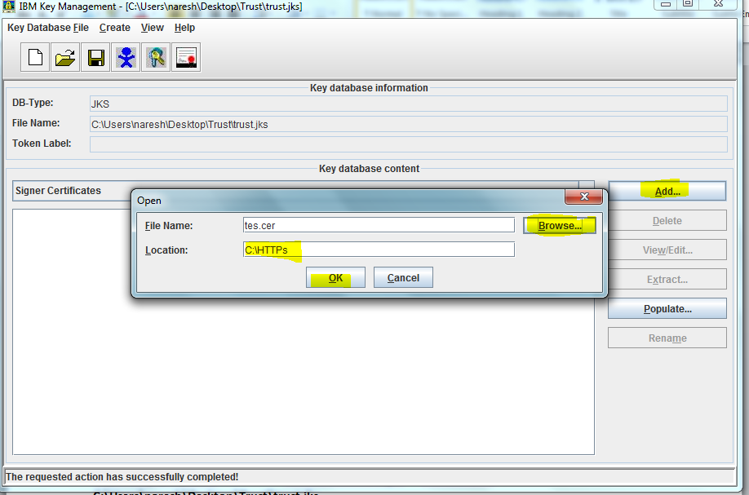

Click on add

Choose downloaded certificate path

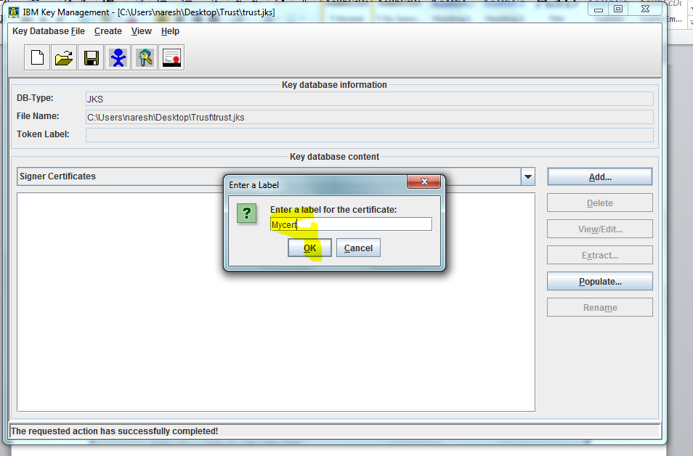

Give any name

**mqsichangeproperties TEST -e t -o ComIbmJVMManager -n truststoreFile -v C:\Users\naresh\Desktop\Trust\trust.jks**

**mqsichangeproperties TEST -e t -o ComIbmJVMManager -n truststorePass -v defaultTruststore::password**

In below command use password which we gave in truststore password

**mqsisetdbparms TEST -n defaultTruststore::password -u ignore -p password**

**stop & start node**

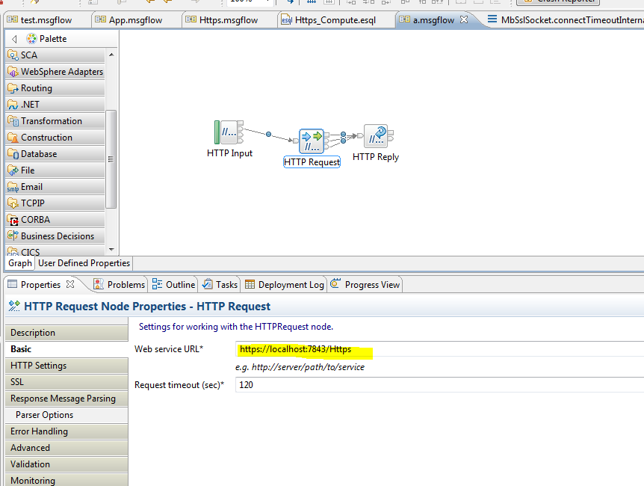

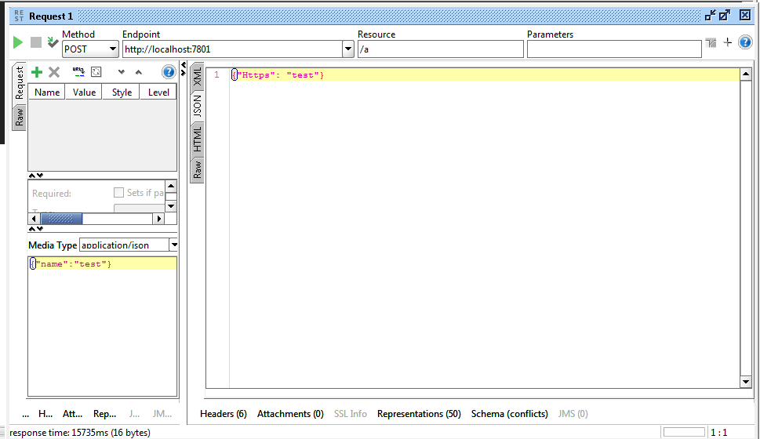

**Above all procedure is only one time setup.If we have to integrate any other https service in that case First download certificate shown in step 1**

**Open console type ikeyman enter**

**Click on open**

**Click on browse select the truststore(which we created in step 2) location click**

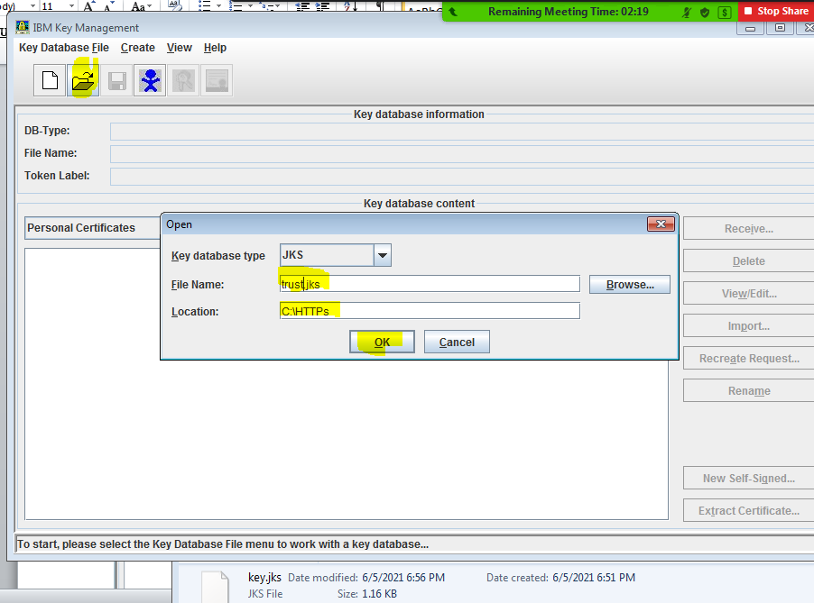

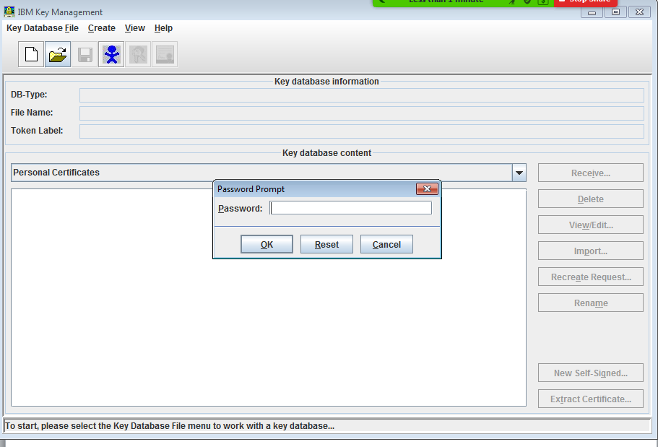

**Give password**



**Choose location where we downloaded certificate**

**If required stop & start Node**